|  |  |
| --- | --- |
| **Practicum Case** |  |
| MATH6183 | MATH6183001 | MATH6183016 | MATH6183049  Scientific Computing |
| **Mathematics & Statistics** | **E231-MATH6183-JJ01-04** |
| ***Valid on*** *Even Semester Year 2023/2024* | **Revision 00** |

## Learning Outcomes

* LO3 – evaluate the application of taylor series and root of equations in scientific computation

## Topic

* Session 04 – Root of Equations

## Sub Topics

* Newton-Raphson Method
* Bisection Method

## Soal

*Case*

1. **Newton Raphson**

Find the **root of the equation** from the equation f(x) below by using **Newton Raphson** method:

$$f\left(x\right) : x^{6}+2x^{2}-3$$

* How many **iterations** are required to find the root of the equation?
* With **first guess** of the value is **4**.
* With **tolerate error** is **0.01**.
* With the number of the **max iterations** is **15**.
* **Print the result** of the **root** in **each** **iteration**. If the iteration is **over the max** iterations the **print error message**.

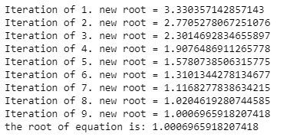

**Figure 1. Newton Raphson Result with Tolerate Error 0.01**

1. **Bisection**

Find the **root of the equation** from the equation f(x) below by using **Bisection** method:

$$f\left(x\right) : 10x^{3}+8x^{2}+9$$

With the following **coordinates** **x1** and **x2** are:

1. x1 = 3, x2 = 4
2. x1 = -10, x2 = 17
3. x1 = 10, x2 = -15
4. x1 = -2, x2 = 4
5. x1 = 12, x2 = -5
6. x1 = -8, x2 = -13
7. x1 = 7, x2 = -21

coordinates = [

    [3, 4],

    [-10, 17],

    [10, -15],

    [-2, 4],

    [12, -5],

    [-8, -13],

    [7, -21],

]

* Find the **root of each coordinate**.
* **Print** the **result of the** **root** in each iteration of coordinates.
* With **tolerate error** is **0.001**.
* For each iteration of coordinates, **validate** coordinate **x1 and x2** must **not be the same sign**.

**Figure 2. Root of the Equation of Each Coordinate with Bisection**